
RAJIV GANDHI COLLEGE OF ENGINEERING AND TECHNOLOGY
DEPARTMENT OF I YEAR ENGINEERING
MODEL EXAM
SET- I -T111-ENGINEERING MECHANICS
PART-A (10X2=20)
(Answer all the questions)
- Differentiate Equilibrium and Equilibrant.
- Two concurrent forces act at an angle of 30⁰. The resultant force is 15N and one of the forces is 10N. Find the other force.
- State any two coulomb’s laws of dry friction.
- Define angle of friction and angle of repose.
- Define Polar Moment of Inertia.
- Define Mass Moment of Inertia.
- Define coefficient of restitution.
- A body is moving with a velocity of 2 m/s. After 4 seconds, the velocity of the body becomes 5 m/s. Find the acceleration of the body.
- A wheel rotating about a fixed axis at 20rpm is uniformly accelerated for 70 sec, during which time it takes 50 revolutions. Find the final angular velocity of the wheel.
- What is general plane motion? Give two examples.
PART-B (11X5=55)
(Answer all the questions)
UNIT-I
- a) Forces of 2N, 3N, 4N, 5N and 6N are acting at one of the angular points of a regular hexagon towards the other angular points taken .Find the resultant force. (5)

b.) A fine light string ABCDE whose extremity A is fixed, has weight W₁ and W₂ attached to it at B and C. It passes round a small smooth peg at D carrying a weight of 40N at the free end E as shown in fig. If in the position of equilibrium, BC is horizontal and AB and CD makes 150⁰ and 120⁰ with BC, find a.) Tension in the portion AB, BC and CD of the string and b.) Magnitude of W₁ and W₂. (6)
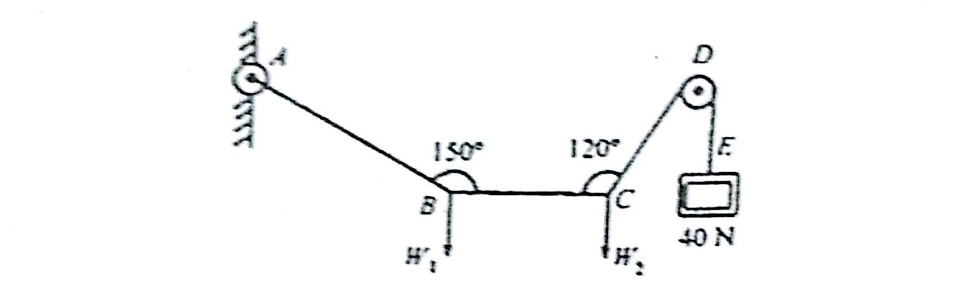
(Or)
- Three smooth pipes each weighing 20KN and of diameter 60 cm are to be placed in a rectangular channel with horizontal base as shown in fig. Calculate the reactions at the points of contact between the pipes and between the channel and the pipes. Take the width of the channel is 160 cm.
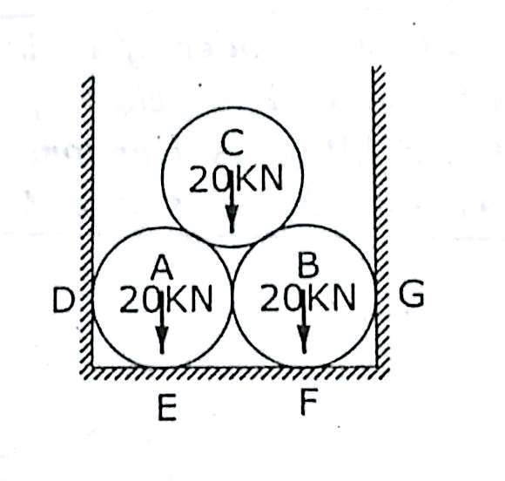
UNIT-II

- Analyze the truss shown in fig. using method of joints tabulate the results. (11)
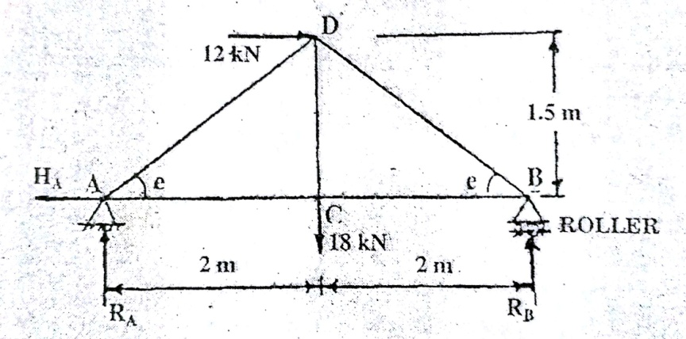
(OR)
- The ladder shown in fig is 6m long and is supported by a horizontal floor and vertical wall. The coefficient of friction between the floor and the ladder is 0.4 and between wall and ladder is 0.25. The weight of the ladder is 200N and may be considered as concentrated at G. The ladder also supports a vertical load of 900N at C, which is at a distance of 1m from B. Determine the least value of α at which the ladder may be placed without slipping. Determine the reaction at that
Stage. (11)
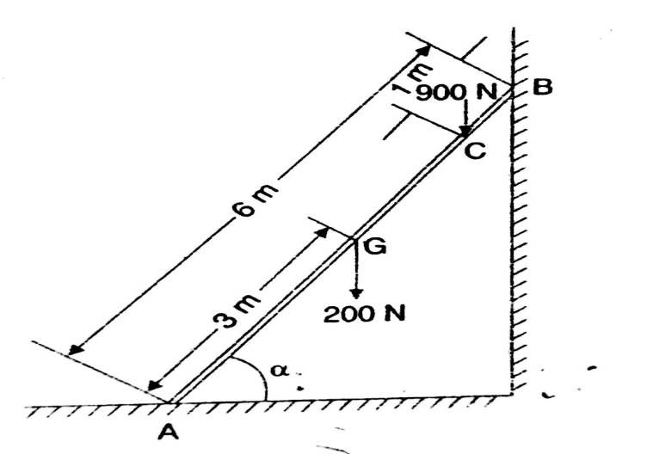
UNIT-III
- Determine the polar moment of inertia about the centroidal axes of the I section shown in fig. Also determine the radius of gyration with respect to x-x and y-y axes. (11)

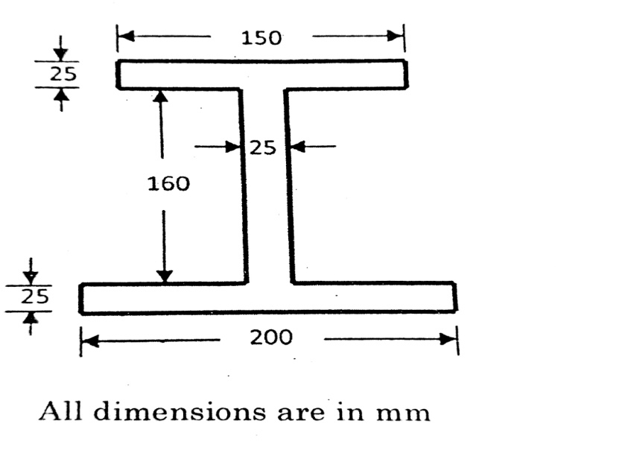
(Or)
- Find the centroid of the lamina shown in fig. (11)

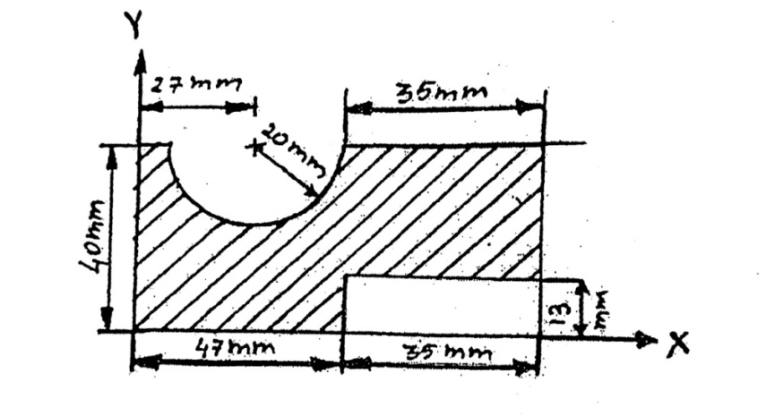
UNIT-IV

- a.) A particle under constant deceleration is moving in a straight line and covers a distance of 20m in the first two seconds and 40m in the next 5 seconds. Calculate the distance it covers in the subsequent 3 seconds. (6)

b.) A bus is beginning to move with an acceleration of 0.3m/s².A man who is 12m behind the bus starts running at 3m/s to catch the bus. After how many seconds will the man be able to catch the bus? (5)
(Or)
- a.) Two bodies one of which is 200N with a velocity of 10 m/s and the other of 100N with a velocity of 10m/s move towards each other and impinge centrally. Find the velocity of each body after impact, if the coefficient of restitution is 0.6. Find also the loss in kinetic energy due to impact. (5)

b) Two weights 800N and 200N are connected by a thread and move along a rough horizontal plane under the action of force 400N, applied to the first weight of 800N as shown in fig. The co-efficient of friction between the sliding surfaces of the weights and the plane is 0.3. Determine the velocity of the system after 2 sec. Also calculate the tension in the string using impulse-momentum equation. (6)

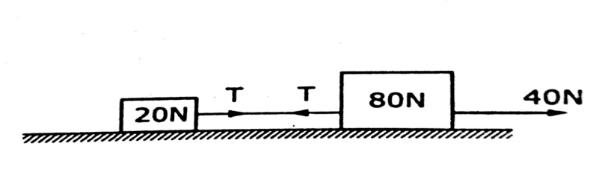

UNIT-V

- A wheel is attached to the shaft of an electric motor of rated speed of 2000 rpm. When the power is switched on the unit it attains the rated speed in 10seconds and when the power is switched off, the unit comes to rest in 100seconds. Assume uniformly accelerated motion and determine
- The number of revolutions unit turns to attain the rated speed, and
- The number of revolution the unit comes to rest. (11)
(Or)
- Two blocks A and B of mass 250 kg and 200 kg are connected by a string which passes over a frictionless disc of mass 50kg as shown in fig. Calculate the velocity of the blocks after 5 seconds, when they are released from rest. (11)
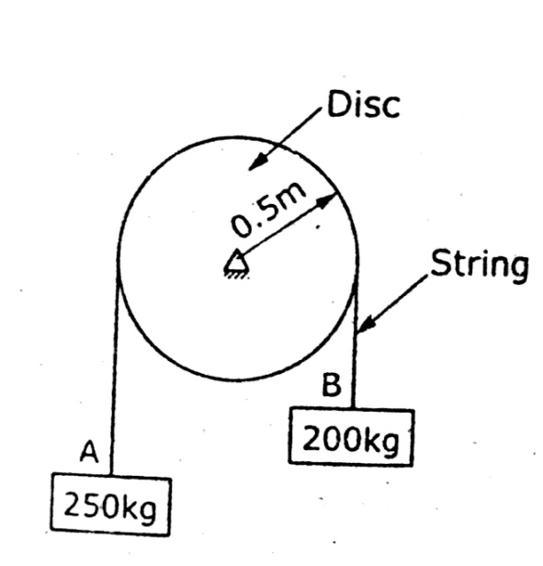


RAJIV GANDHI COLLEGE OF ENGINEERING AND TECHNOLOGY
DEPARTMENT OF I YEAR ENGINEERING
MODEL EXAM
SET II- T111-ENGINEERING MECHANICS
(Answer all the questions)
PART-A (10X2=20)
- Define Parallelogram law of forces.
- State Principle of Transmissibility of forces.
- What are the different types of loads?
- Define coefficient of friction
- Define Radius of Gyration.
- State Parallel Axis Theorem.
- State D’Alembert’ Principle.
- The equation of motion a body is 5t³+4t²+3t+2.Find the velocity and acceleration.
- A flywheel of radius 1.5m is rotating with a speed of 1000 rpm. Calculate the angular velocity and linear velocity.
- A body is rotating with an angular velocity of 5 rad/sec. After 4 seconds, the angular velocity of the body becomes 13 rad/sec. Determine the angular acceleration of the body.
PART-B (11X5=55)
UNIT-I
- If five forces act on a particle as shown in fig and the algebraic sum of horizontal components of all these forces is -324.904KN, calculate the magnitude of P and the resultant of all the forces. (11)
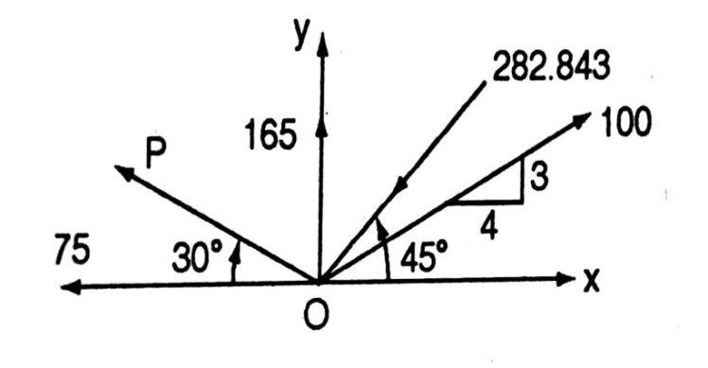
(Or)

- Four forces of magnitude and direction acting on a square ABCD of side 2m are shown in fig. Calculate the resultant in magnitude and direction and also locate its point of application with respect to the sides AB and AD. (11)
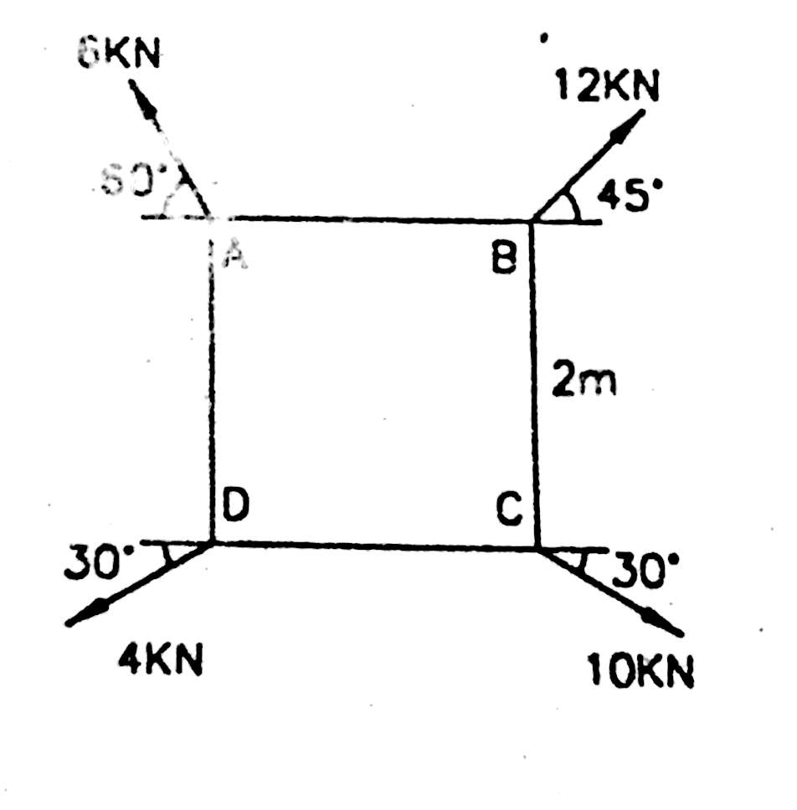
UNIT-II

- Determine the support reaction of the simply supported beam subjected to the loads and shown in fig. (11)
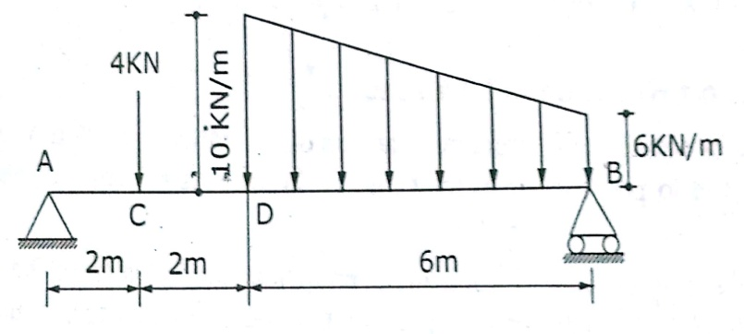
- What is the value of P in the system shown in fig to cause the motion to impend? Assume the pulley is smooth and coefficient of friction between the other contact surfaces is 0.20. (11)
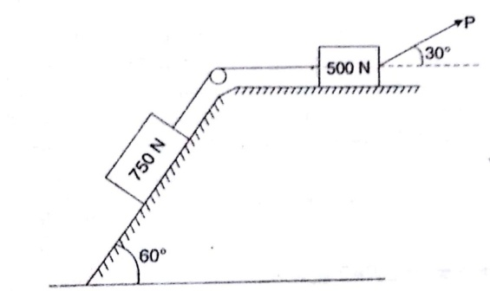

UNIT-III

- Determine the coordinates of the centroid of the plane area shown in fig with reference to the axes shown.Take x= 40 mm. (11)
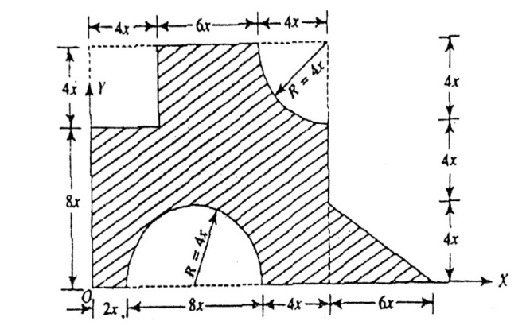

(Or)
- Find the moment of inertia about the centroidal XX and YY axes. (11)

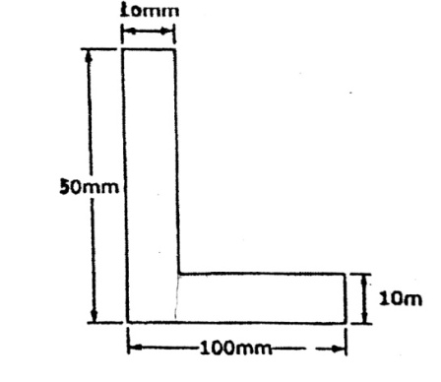
UNIT-IV

- A Train is travelling from A to D along the track. Its initial velocity at A is zero. The train takes 5 min to cover the distance AB, 2250 m length and 2.5 min to cover the distance BC, 3000 m in length, on reaching the station C, the brakes are applied and the train stops 2250 m beyond, at D
- Find the retardation on CD,
- The time it takes the train to get from A to D
- Its average speed for the whole distance. (11)
(Or)
- Two blocks A and B of weight 120N and 100N are hung to the ends of a rope, which is passed over an ideal pulley as shown in fig. the velocity of the system is increases from 1 m/s to 2m/s. How much the distance, these blocks will move? Also calculate the tension in the string? Use work-energy method.
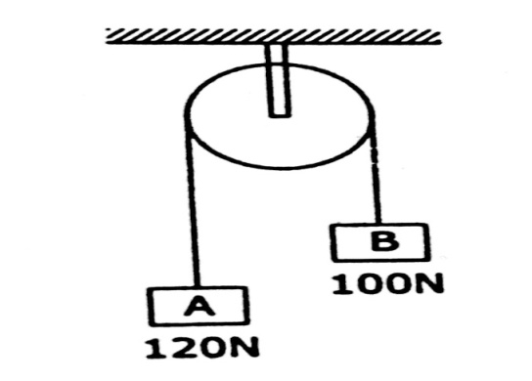

UNIT-V

- The rotation of a flywheel is governed by the equation
ω=3t²-2t+2 where ω is in radian per second and t is in seconds. After one second from the start the angular displacement was 4 radians. Determine the angular displacement, angular velocity and angular acceleration of the flywheel when t=3 seconds. (11)
(Or)
- A road roller of weight 11772 N and radius 0.5 m is pulled with a force of 2000N on a rough ground. If the roller starts from rest and rolls without slipping find the distance moved by the centre if the roller at which roller acquires a velocity of 4m/s.
(11)
